**Part 1: Simple Queries:**

INSERT INTO Locations (Location_Name, Address, Phone_Number)

VALUES ('Downtown Branch', '123 Main St, Cityville', '555-1234');

INSERT INTO Locations (Location_Name, Address, Phone_Number)

VALUES ('Airport Branch', '456 Airport Rd, Cityville', '555-5678');

ALTER TABLE Cars

ADD Location_ID NUMBER REFERENCES Locations(Location_ID);

ALTER TABLE Rental_Transactions

ADD Location_ID NUMBER REFERENCES Locations(Location_ID);

INSERT INTO Cars (Make, Model, Year, License_Plate, VIN, Daily_Rental_Price, Availability_Status, Location_ID)

VALUES ('Toyota', 'Camry', 2020, 'ABC123', '1HGBH41JXMN109186', 45.00, 'Available', 1); -- assuming 1 is Downtown Branch

INSERT INTO Cars (Make, Model, Year, License_Plate, VIN, Daily_Rental_Price, Availability_Status, Location_ID)

VALUES ('Toyota', 'Camry', 2020, 'ABC123', '1HGBH41JXMN109186', 45.00, 'Available', 1); -- assuming 1 is Downtown Branch

## **1. Select All Distinct Last Names**

SELECT DISTINCT Last_Name

FROM Customers

ORDER BY Last_Name;

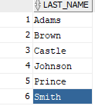

## **2. Number of Available Cars by Make**:

SELECT Make, COUNT(*) AS NumberOfCars

FROM Cars

WHERE Availability_Status = 'Available'

GROUP BY Make

ORDER BY NumberOfCars DESC;

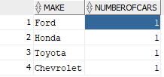

## **3. Count of Rental Transactions by Status**:

SELECT Status, COUNT(*) AS TotalRentals

FROM Rental_Transactions

GROUP BY Status

ORDER BY Status;



## **4. Total Payment Amount by Payment Method**:

SELECT Payment_Method, SUM(Payment_Amount) AS TotalPaid

FROM Payments

GROUP BY Payment_Method

ORDER BY TotalPaid DESC;

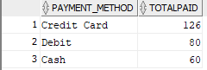

## **5. Average Maintenance Cost by Description**:

SELECT Description, AVG(Maintenance_Cost) AS AverageCost

FROM Car_Maintenance

GROUP BY Description

ORDER BY AverageCost DESC;

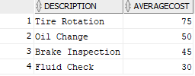

## **6. Unique Location Names and Addresses**:

SELECT DISTINCT Location_Name, Address

FROM Locations

ORDER BY Address;

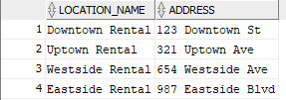

## **7. Total Rentals per Customer**:

SELECT c.First_Name, c.Last_Name, COUNT(r.Rental_ID) AS TotalRentals

FROM Customers c

LEFT JOIN Rental_Transactions r ON c.Customer_ID = r.Customer_ID

GROUP BY c.First_Name, c.Last_Name

ORDER BY TotalRentals DESC;

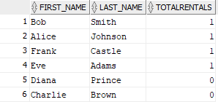

## **8. Maintenance Count per Car Make and Model**:

SELECT c.Make, c.Model, COUNT(cm.Maintenance_ID) AS MaintenanceCount

FROM Cars c

LEFT JOIN Car_Maintenance cm ON c.Car_ID = cm.Car_ID

GROUP BY c.Make, c.Model

ORDER BY MaintenanceCount DESC;

